PUNE DISTRICT EDUCATION ASSOCIATION’S
SETH GOVIND RAGHUNATH SABLE COLLEGE OF PHARMACY
SASWAD, DIST-PUNE
Report on celebration of WORLD AIDS Day (02/12/2020)
Every year World AIDS Day is celebrated on 1st December since 1988 for to raise awareness, educate and improve the understanding about HIV/AIDS as a global public health problem . PDEA’s SGRS College of Pharmacy, Saswad in association with Public Health Hospital (PHC), Saswad celebrated world AIDS day by performing health check-up camp including HIV test, Blood sugar and oxygen level of all the staff members and M. Pharm. Students. Total 50 participants were performed their test in this camp. Mr. Shelke, Counsellor, PHC, Saswad, Mrs. Swati Waghole, Lab-technician, PHC, Saswad and Mrs. Aasha Kumbharkar, Swadamini Sanstha were present during this day. The heath check-up camp was inaugurated by Dr. S. J. Pawar, Vice Principal. The camp was successfully organized under the guidance of Principal Dr. R. S. Chavan and coordinated by Prof. J. R. Jagtap, Cultural Incharge.

Mrs. J. R. Jagtap Dr. R. S. Chavan
Cultural Incharge Principal

Photo Gallery

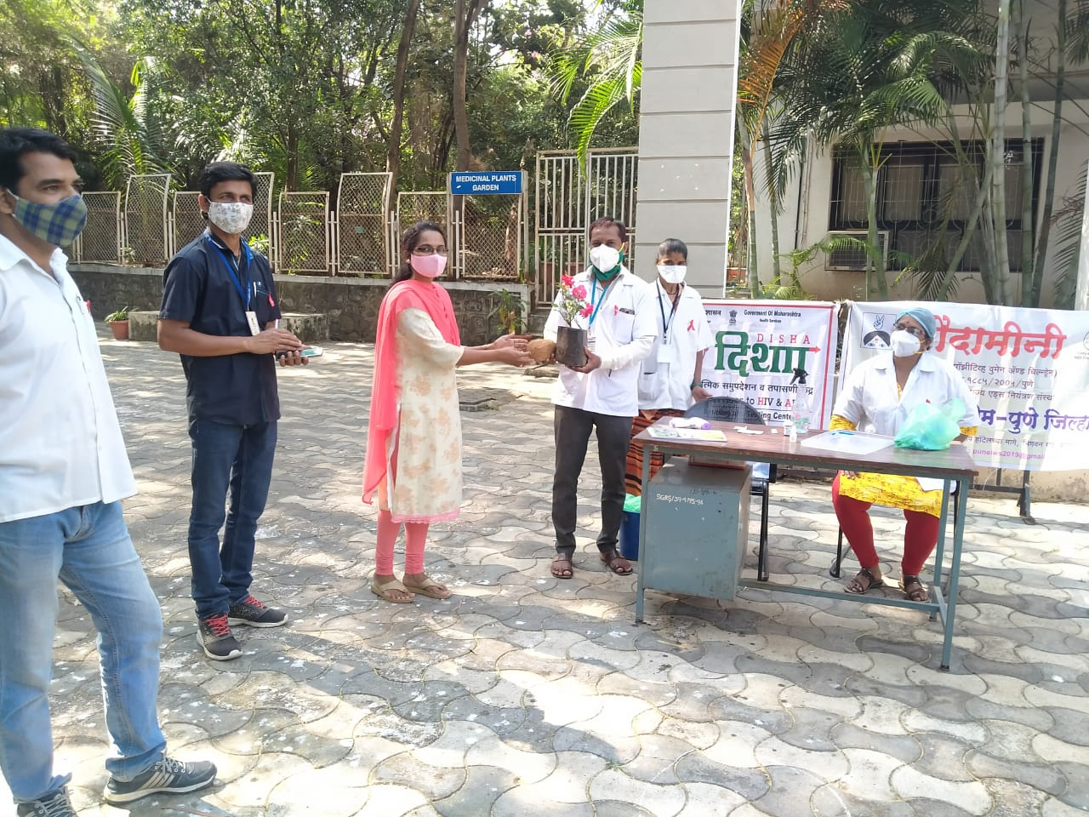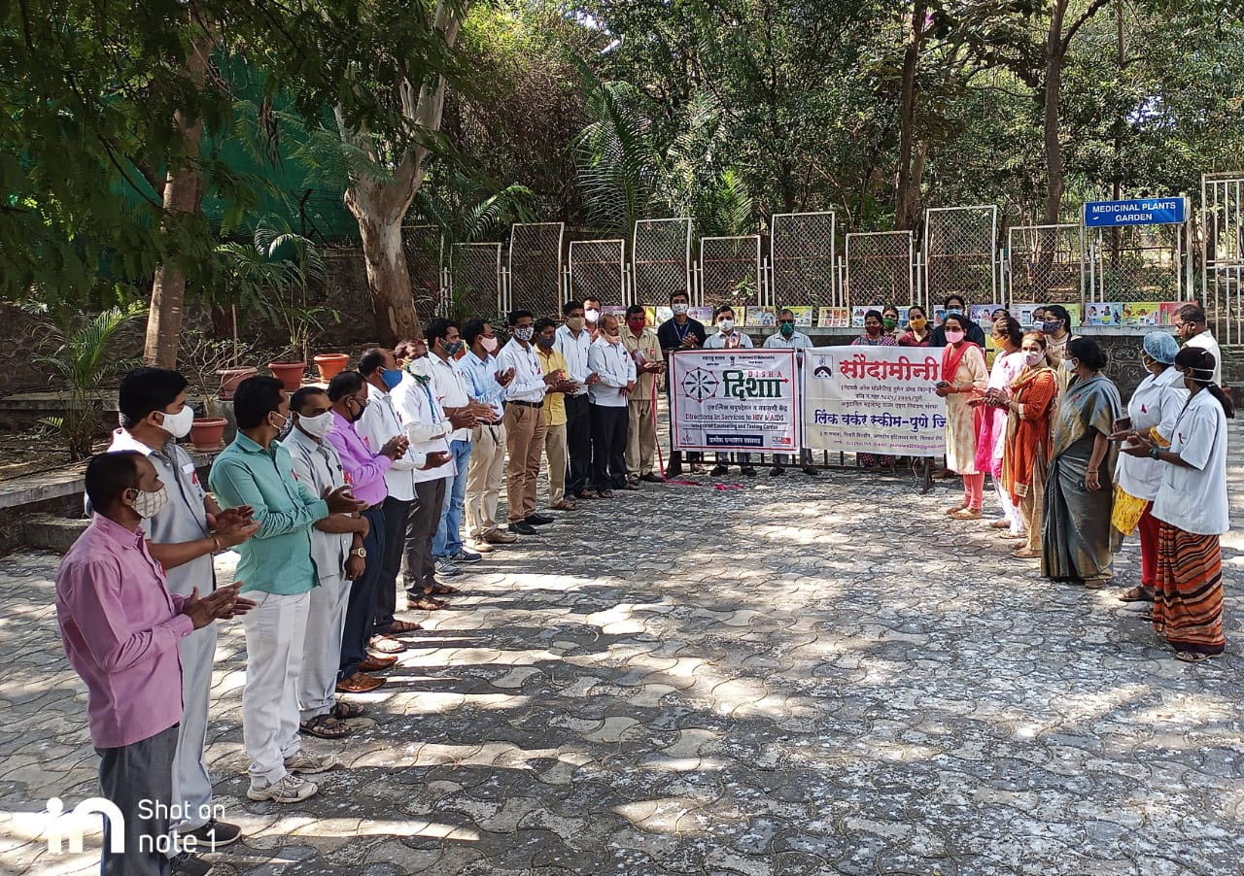

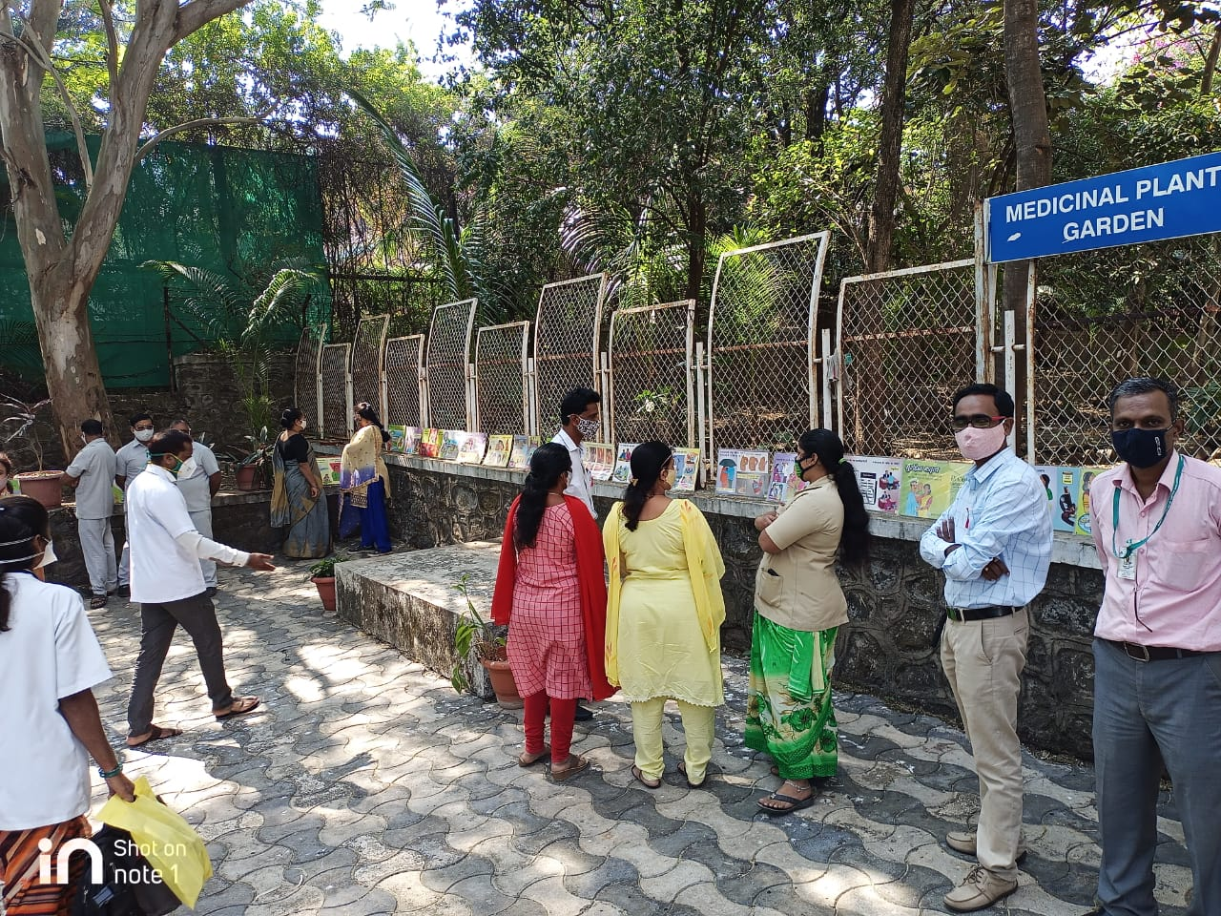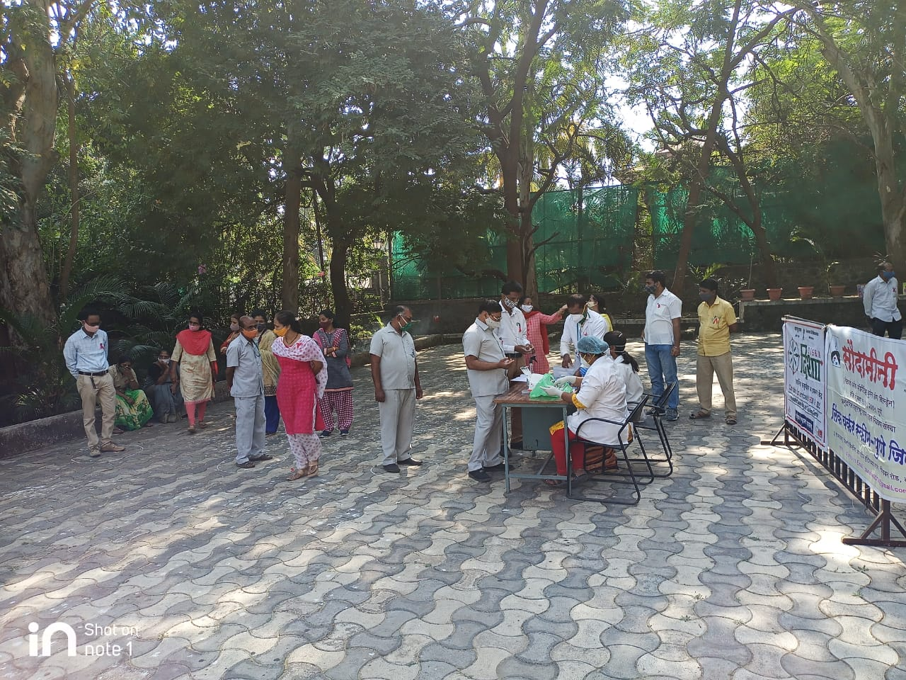

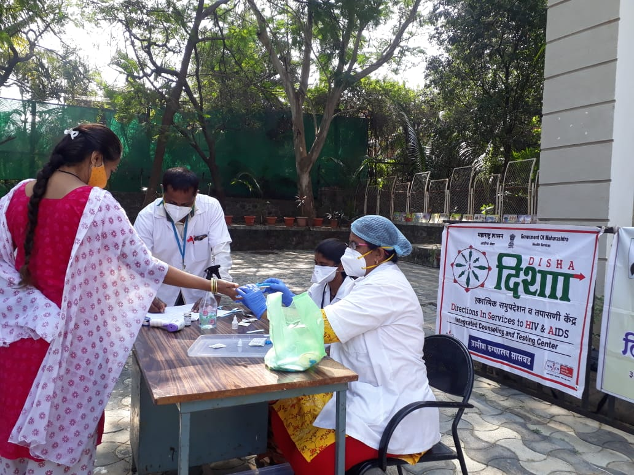
PUNE DISTRICT EDUCATION ASSOCIATION’S
SETH GOVIND RAGHUNATH SABLE COLLEGE OF PHARMACY
SASWAD, DIST-PUNE

E-Presentation Competition on the Occasion of WORLD AIDS Day (09/12/2020)
The E-Presentation competition organized by the institute in association with Public Health Hospital, Saswad on the Occasion of World AIDS Day on 09/12/2020 at 2.00 p.m. to 3.30 p.m. using online platform Zoom app. Total 18 students from D. Pharm., B. Pharm. and M. Pharm participated in this competition. The E- Presentations were evaluated by. Dr. Urmila Chikane
AYUSH department, Rural Hospital, Saswad and Mrs. Swati Waghole, Lab- Technician, ICTC
Rural Hospital, Saswad. The best E-presentation of all classes were declared as winners of E- Presentation competition. The result of E- Presentation competition is as follows.

Sr. No. | Name of Class | Name of Student | Result
1 | M. Pharm. | Pranesh Pandurang Memane | Winner
2 | B. Pharm. | Ritusha Rajendra zagade | Winner
3 | D. Pharm. | Rutuja Ramdas Kaswed | Winner

Ms. Pooja Pisal Mrs. J. R. Jagtap Dr. R. S. Chavan
Co- Coordinator Cultural Incharge Principal
Photo Gallery

